Paolo Bafico
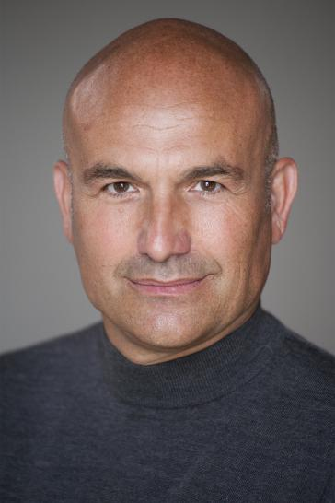
24 Alderley Road, Hoylake, Wirral, CH47 2AX
Email : paolobafico@gmail.com
mobile 07903032927
I moved from Dublin a few years ago where I had gained some experience both as an extra ( featured and non) and commercial model.
Some of the work I have been involved in includes:
- O2 campaign ( newspaper and TV advert)
- Paddy’s Whiskey ( newspaper advert)
- Permanent TSB ( TV advert)
- The Tiger’s Tail
- Asylum
- The Tudors
- Rock Rivals ( Channel 4 Episode 4, Walk on 3 as US businessman)
- The Flight of The Earls (TV documentary, Stephen Rea as lead actor) Walk on 2 head of Spanish army

I then had to put a pause to this line of work due to business and personal priorities,
Since starting again to work here in July 2018 I have been involved in the following work:

- Holly Oaks ( Walk on 3 , Spanish doorman)
- Deep Water ( ITV production with Anna Friel as lead actress, Walk on 2 as teacher)
- The Feed ( Amazon production with Dave Thewlis as lead actor, Walk on 2 as armed security officer)
- Emmerdale ( Guest at wedding )
- Available Cars ( TV commercial, background)

Skills:
I have a motorbike license and I am trained in the use of firearms ( military service in the Italian Police ); I can ride a horse.
I have played basketball and tennis at competitive level; I am bl-lingual ( Italian and English) and speak French and Spanish ( intermediate)
I am available to travel across UK and mainland Europe at short notice.

Kind regards,
Paolo Bafico

